Programming and operating the Baofeng F8 and F5 handhelds.
- Downloading the program CHIRP software is recommended. It is free and It makes programming the radios much easier. With the CHIRP program you can use the repeater query to find local repeaters. https://chirp.danplanet.com/projects/chirp/wiki/Download
- To use the CHIRP software, you will also need a Baofeng cable available through Amazon for $9.99.
- Everyone needs to practice programming their own radios by hand, but your communications officer will be able to program them with CHIRP.
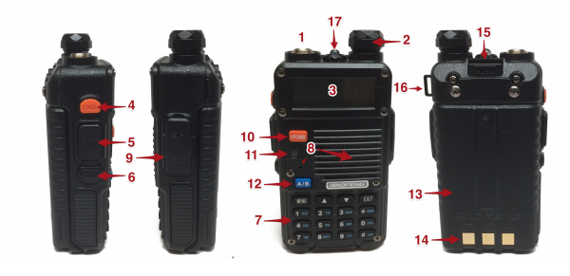
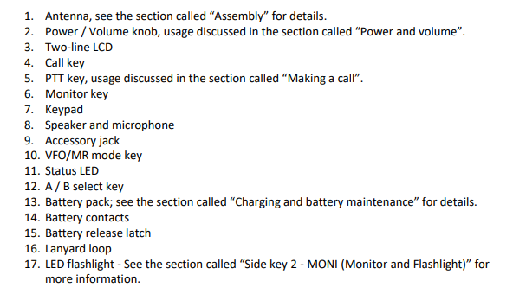

Button number 10 (VFO/MR) changes the radio between Channel Mode and Frequency mode.
Frequency Mode allows you to manually type in the frequency you want to listen or transmit on.
Channel (Memory) Mode is where you can select your saved frequencies (channels)
Button number 12 is the A/B button. It allows you to switch between the top frequency or low frequency on the main screen.
Scan button (*scan) Press and hold the scan button when you are in Channel Mode, and it will scan all the saved frequencies in the radio. Press and hold the scan button in the Frequency Mode, and it will start scanning from the frequency that shows on the screen.

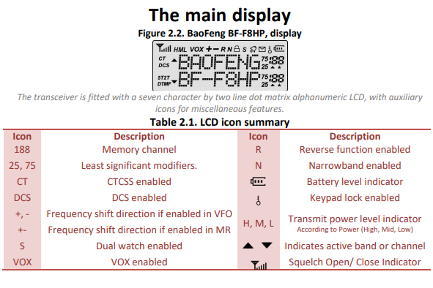

Simplex
Simplex-This is when you pick one frequency to transmit on. A couple of people or a group can be tuned into this frequency, but only one can talk at a time.
Remember, transmitting without a license is illegal. When transmitting, your message should be short and to the point. The less time you spend talking gives others the opportunity to call in.
During training exercises the phrase” THIS IS AN EXERCISE” must be called at the end of each transmission. This alerts anyone possibly listening in that we are training, and it is not a real emergency.

How to manually program a simplex channel
- Step 1. Press [VFO/MR] and enter Frequency Mode.
- Step 2. Press [A/B] and choose the A Side (upper display).
The A side must be used to program channels into the radio. Programming data entered on the B Side (lower display) will not be saved.
- Step 3. Press [BAND] for the frequency band.
Toggle [BAND] to choose 136 MHz (VHF) or 470 MHz (UHF).
If the incorrect band is chosen for the frequency entered in Step 5, the radio will cancel the operation.
- Step 4. Disable TDR (Dual Watch/Dual Standby).
Press [MENU] 7 [MENU] [press up/down arrow keys] OFF [MENU] [EXIT]
It is highly advised to turn TDR off when programming directly from the radio.
- Step 5. Enter the frequency.
Use the keypad to enter the frequency into the radio.
- Step 6. Assign the frequency to a channel.
[MENU] 27 [MENU] [enter channel number XXX] [MENU] [EXIT]
Repeaters
Repeaters are not as complicated as they seem. It is basically a high-power transmitter that listens on one channel and transmits on another. You transmit to the repeater with your lower wattage radio, and it sends the message out with a high-power transmitter. Setting these up can seem a little complicated but it is not. Your communications officer can walk you through the process.
Remember, you can send a call out on the receiver, but the individual receiving it may be out of range and unable to send a reply.
Receiver offset refers to the two frequencies used by the repeater. The repeater input is either lower (usually 600kHz) or higher (usually 600 kHz). If the offset is lower the radio offset is set to (-) or if it is higher it is set to (+). If the repeater is 139.000, then the input channel will be 139.600 for a positive shift or 138.400 for a negative shift.
Entering + or – in your offset settings (settings menu #25) tells your radio to go up or down in frequency when transmitting. Your factory settings in your radio should already have the 600kHz offset set. If not, you can change this in the (settings menu #26)

Commonly Used Menu Items
0 | SQL | RF Squelch
2 | TXP | Transmit power (Tap # to temporarily change power)
11 | R-CTCS | Receive CTCSS (PL)
13 | T-CTCS | Transmit CTCSS (PL)
25 | SFT-D | Repeater Shift Direction
26 | OFFEST | Repeater Offset (MHz)
27 | MEM-CH | Save to memory channel
28 | DEL-CH | Delete memory channel

How to manually program a repeater channel
- Step 1. Press [VFO/MR] and enter Frequency Mode.
- Step 2. Press [A/B] and choose the A Side (upper display).
Like the simplex channels, the A side must be used to program the repeater channels into the radio. Programming data entered on the B Side (lower display) will not be saved.
- Step 3. Press [BAND] for the frequency band
Toggle [BAND] to choose 136 MHz (VHF) or 470 MHz (UHF).
If the incorrect band is chosen for the frequency entered in Step 6, the radio will cancel the operation.
- Step 4. optional - Clear any CTCSS/DCS codes previously assigned to the channel.
If no previous codes exist or when setting up the channel for the first time and no codes are needed, set the menu items listed below to OFF.
  - RX DCS - [MENU] 10 [MENU] [enter 0 (OFF)] [MENU] [EXIT]
  - RX CTCSS - [MENU] 11 [MENU] [enter 0 (OFF)] [MENU] [EXIT]
  - TX DCS - [MENU] 12 [MENU] [enter 0 (OFF)] [MENU] [EXIT]
  - TX CTCSS - [MENU] 13 [MENU] [enter 0 (OFF)] [MENU] [EXIT]
- Step 5. Disable TDR (DualWatch/Dual Standby).
Press [MENU] 7 [MENU] [press up/down arrow keys] OFF [MENU] [EXIT]
It is highly advised to turn TDR off when programming directly from the radio.
- Step 6. optional - Delete any existing data on the channel to program.
Skip this step when setting up the channel for the first time. Press [MENU] 28 [press up/down arrow keys to choose channel number] [MENU] [EXIT]
It is highly advised to turn TDR off when programming directly from the radio.
- Step 7. Enter the frequency.
Use the keypad to enter the frequency into the radio.
- Step 8. Input the repeater frequency offset.
Press [MENU] 26 [MENU] [enter the offset for 2 meter or 70 cm repeater] [MENU] [EXIT]
- Step 9. Enter the Transmit Frequency Shift.
Press [MENU] 25 [MENU] [enter 1 for positive shift or 2 for negative shift] [MENU][EXIT]
- Step 10. optional - Enter the transmit CTCSS/DCS code.
  - CTCSS - [MENU] 13 [MENU] [enter/choose code XXXX] [MENU] [EXIT]
  - DCS - [MENU] 12 [MENU] [choose code XXXXX] [MENU] [EXIT]
- Step 11. Enter the repeater output frequency.
Use the keypad to enter the frequency into the radio.
- Step 12. Assign the receive frequency to the same channel in Step 6.
[MENU] 27 [MENU] [enter channel number XXX] [MENU] [EXIT]
- Step 13. Press the [*Scan] button to activate Reverse Mode and display the transmit frequency.
- Step 14. Assign the transmit frequency to the channel.
Press [MENU] 27 [MENU] [enter the same memory channel in step 27] [MENU] [EXIT]
- Step 15. Press the [*Scan] button to exit <="" i="">.
Some words and letters are hard to understand over the radio. To ensure that your message is understood, you may want to spell it out using the Phonetic Alphabet. You should say “I SPELL” and then spell the message out.
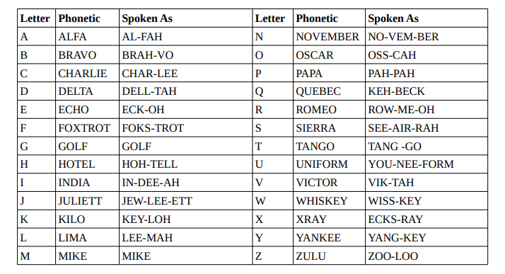
Numbers are sent digit by digit after the Proword “FIGURES”.
